**Part 1.** This question is about a wind turbine.

Air of density ** and speed *v* passes normally through an area *A*.

(a) Deduce that the kinetic energy of the air passing through the area per unit time is given by the expression

kinetic energy per unit time = 

Air of constant density 1.2 kg m–3 is incident at a speed of 9.0 m s–1 on the blades of a wind turbine. The turbine blades are each of length 7.5 m. The air passes through the turbine without any change of direction. Immediately after passing through the blades, the speed of the air is 5.0 m s–1 as illustrated below.



The density of air immediately after passing through the blades is 2.2 kg m–3. The turbine and generator have an overall efficiency of 72.

(b) Calculate

(i) the power extracted from the air by the turbine;

(ii) the electrical power generated.

**Part 2.** This question is about solar power.

(a) Describe, in terms of energy transformations, the difference between a photovoltaic cell and an active solar heater.

(b) A photovoltaic cell of area 6.5  10–4 m2 is situated on the roof of a house. The cell has an efficiency of 8%. At a time when the power of the solar radiation incident on the photovoltaic cell is a maximum, the cell delivers a power of 47 mW to the external circuit.

(i) Deduce that the maximum value of the power of the solar radiation incident on the cell is approximately 0.90 kW m–2.

(ii) State **one** reason why the power of solar radiation at any particular region does not have a constant value.

(c) A power of 3.0 kW is required to produce adequate hot water for the house.

(i) Use the data from (b) to determine the minimum area of the photovoltaic cells required to generate this power.

(ii) The efficiency of energy conversion in an active solar heater is 24. Calculate the minimum area of this solar heater required to generate this power.

(iii) State and explain whether it is more practical to use photovoltaic cells or an active solar heater to provide hot water for the house.

**Part 3.** Simple harmonic motion and the greenhouse effect

(a) A body is displaced from equilibrium. State the **two** conditions necessary for the body to execute simple harmonic motion.

1. .........................................................................................................................

2. .........................................................................................................................

(b) In a simple model of a methane molecule, a hydrogen atom and the carbon atom can be regarded as two masses attached by a spring. A hydrogen atom is much less massive than the carbon atom such that any displacement of the carbon atom may be ignored.

The graph below shows the variation with time *t* of the displacement *x* from its equilibrium position of a hydrogen atom in a molecule of methane.

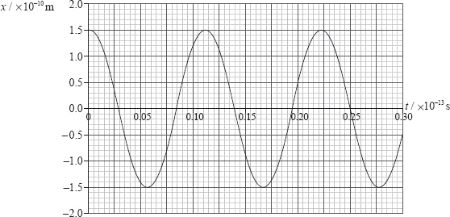

The mass of hydrogen atom is 1.7  10–27 kg. Use data from the graph above

(i) to determine its amplitude of oscillation.

(ii) to show that the frequency of its oscillation is 9.1  1013 Hz.

(iii) to show that the maximum kinetic energy of the hydrogen atom is 6.2  10–18 J.

(c) Assuming that the motion of the hydrogen atom is simple harmonic, its frequency of oscillation *f* is given by the expression



where *k* is the force per unit displacement between a hydrogen atom and the carbon atom and *m*p is the mass of a proton.

(i) Show that the value of *k* is approximately 560 N m–1.

(ii) Estimate, using your answer to (c)(i), the maximum acceleration of the hydrogen atom.

(d) Methane is classified as a greenhouse gas.

(i) Describe what is meant by a greenhouse gas.

(ii) Electromagnetic radiation of frequency 9.1  1013 Hz is in the infrared region of the electromagnetic spectrum. Suggest, based on the information given in (b)(ii), why methane is classified as a greenhouse gas.